Install Prometheus and Grafana on a Linux EC2 machine, connect Prometheus to Grafana, and create a dashboard to view metrics.

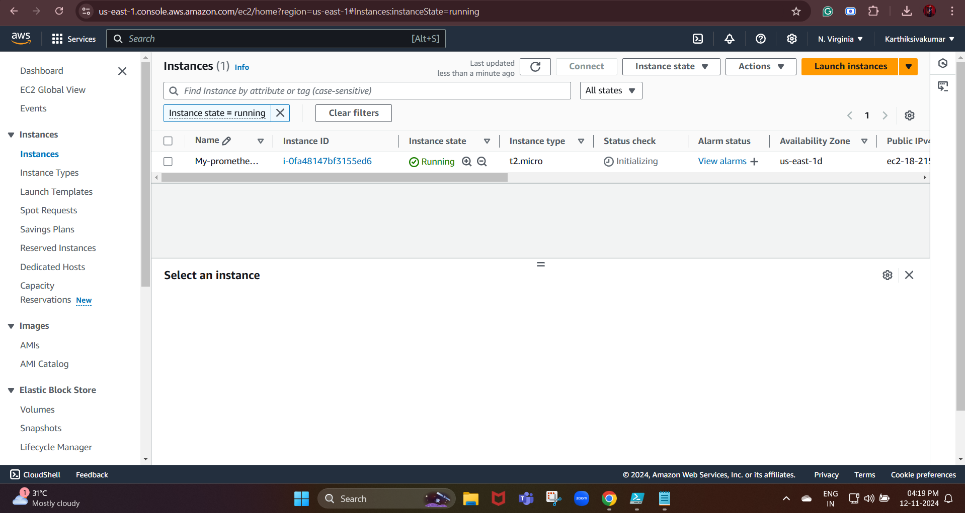

We need to inbound rules in for the required ports:

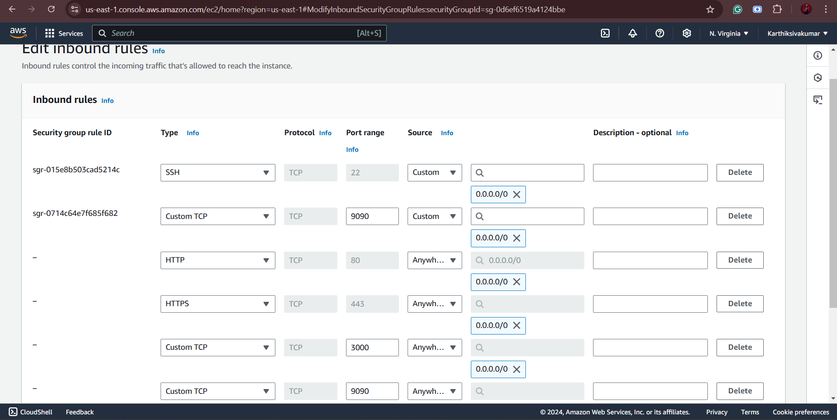

We are going to install Prometheus and grafana through the Linux EC2 machine

Next, we are going to install Prometheus

Prometheus is available as a tar file from GitHub.

Tar file - A tar file is a common archive format used to group multiple files or directories into a single file, making it easier to store or transfer.

We need to use:

wget <https://github.com/prometheus/prometheus/releases/download/v2.43.0/prometheus-2.43.0.linux-amd64.tar.gz>

It downloads the compressed file for the latest version of Prometheus.

wget is a command-line tool for downloading files from the Internet. It supports HTTP, HTTPS, and FTP protocols. It’s commonly used on Linux and Unix-based systems to download files directly from a terminal.

Next, we need to extract the tar file

Command:

**tar -xvzf prometheus-2.43.0.linux-amd64.tar.gz**

Now, we need to move the extracted things to the folder

We are going to change that to the Prometheus directory

**cd prometheus-2.43.0.linux-amd64**

To start the Prometheus

**./prometheus --config.file=prometheus.yml**

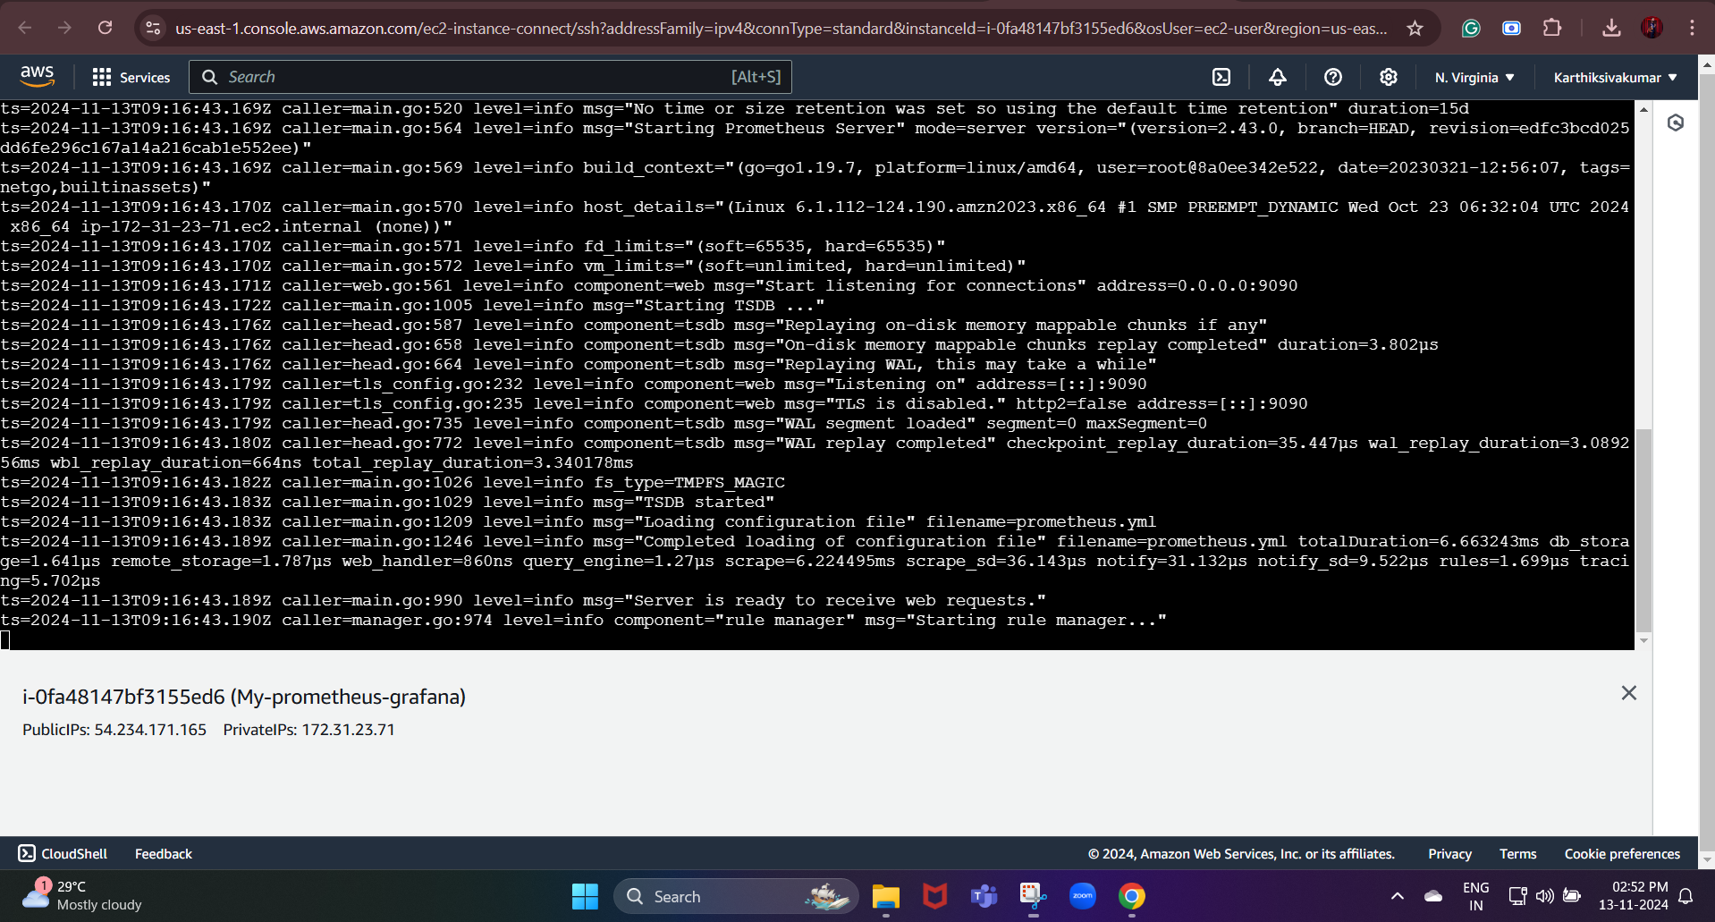

We can verify that by pasting the link on our browser

**http://54.234.171.165:9090**

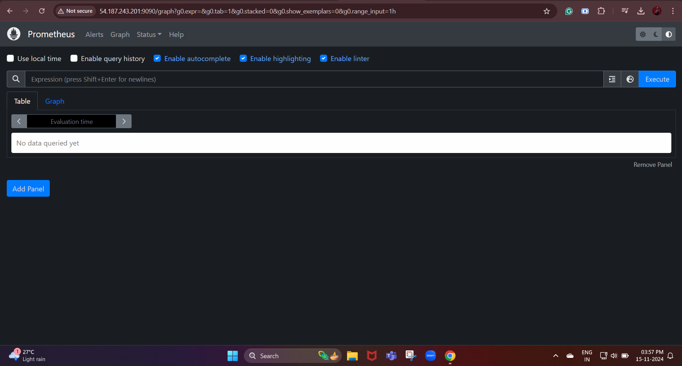

Next, we are going to install grafana in our Linux:

**To install grafana:**

**wget https://dl.grafana.com/enterprise/release/grafana-enterprise-11.3.0+security~01-1.x86_64.rpm**

**sudo yum install grafana**

**sudo /bin/systemctl daemon-reload**

**sudo /bin/systemctl enable grafana-server.service**

**sudo /bin/systemctl start grafana-server.service**

**sudo systemctl status grafana-server.service**

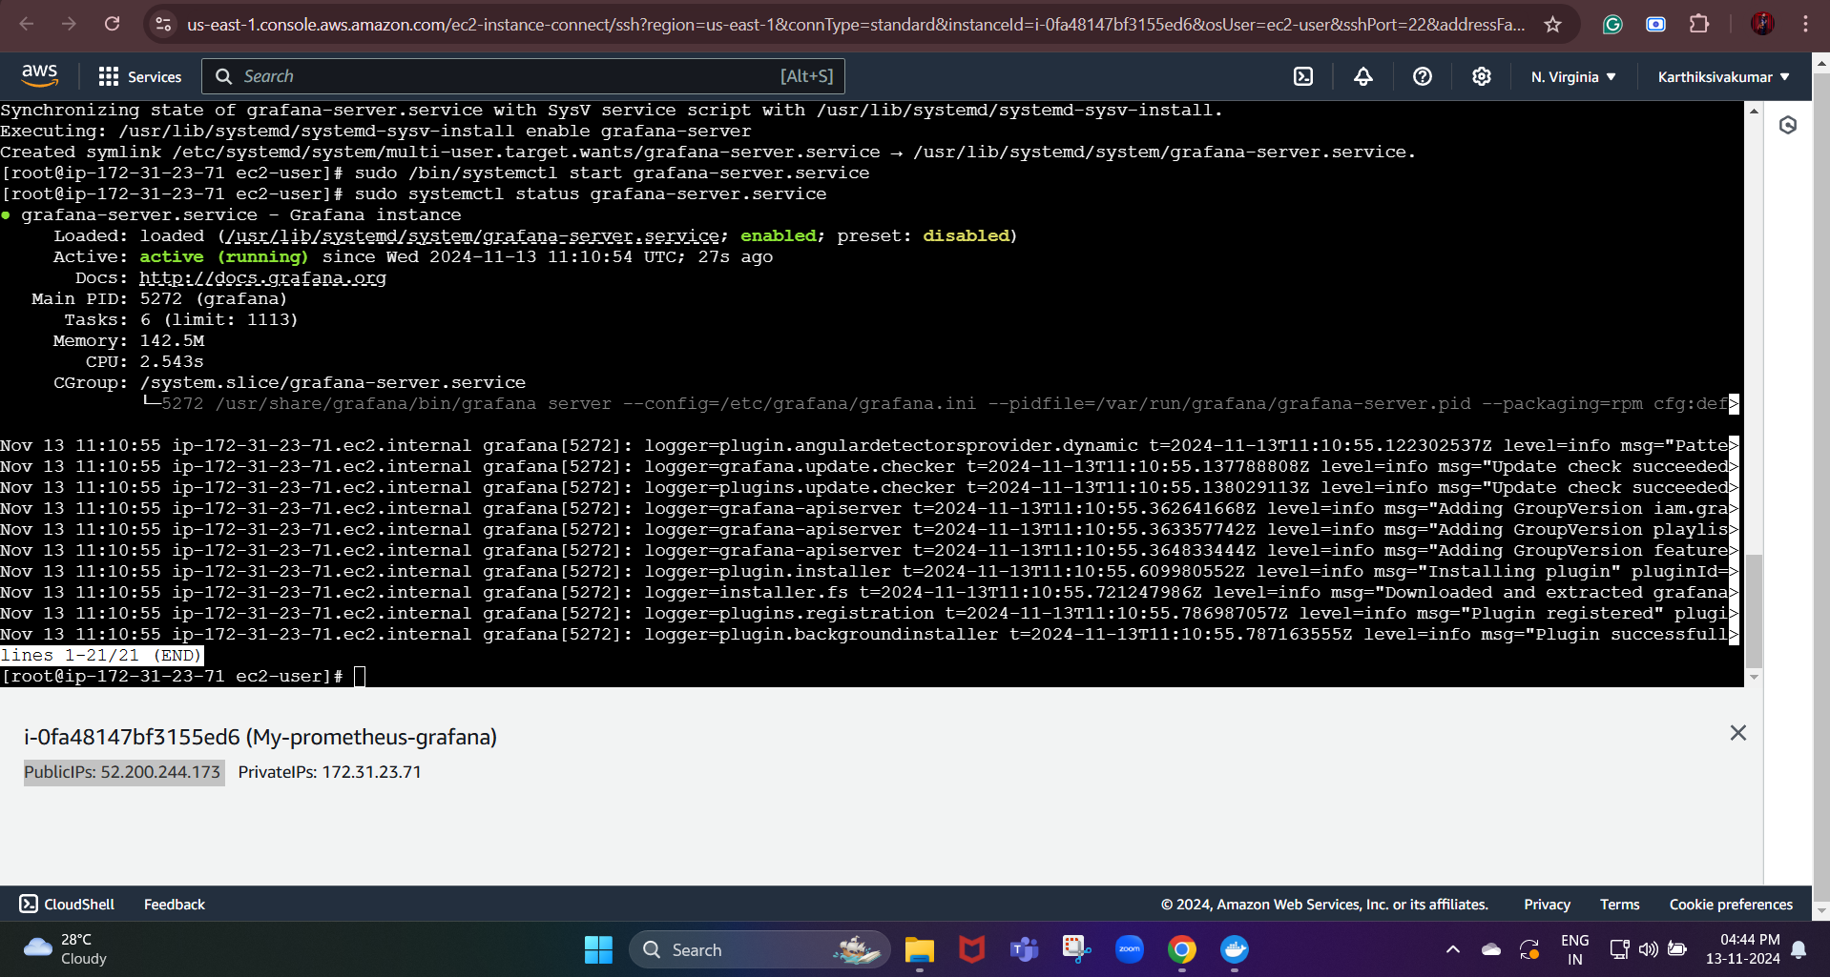

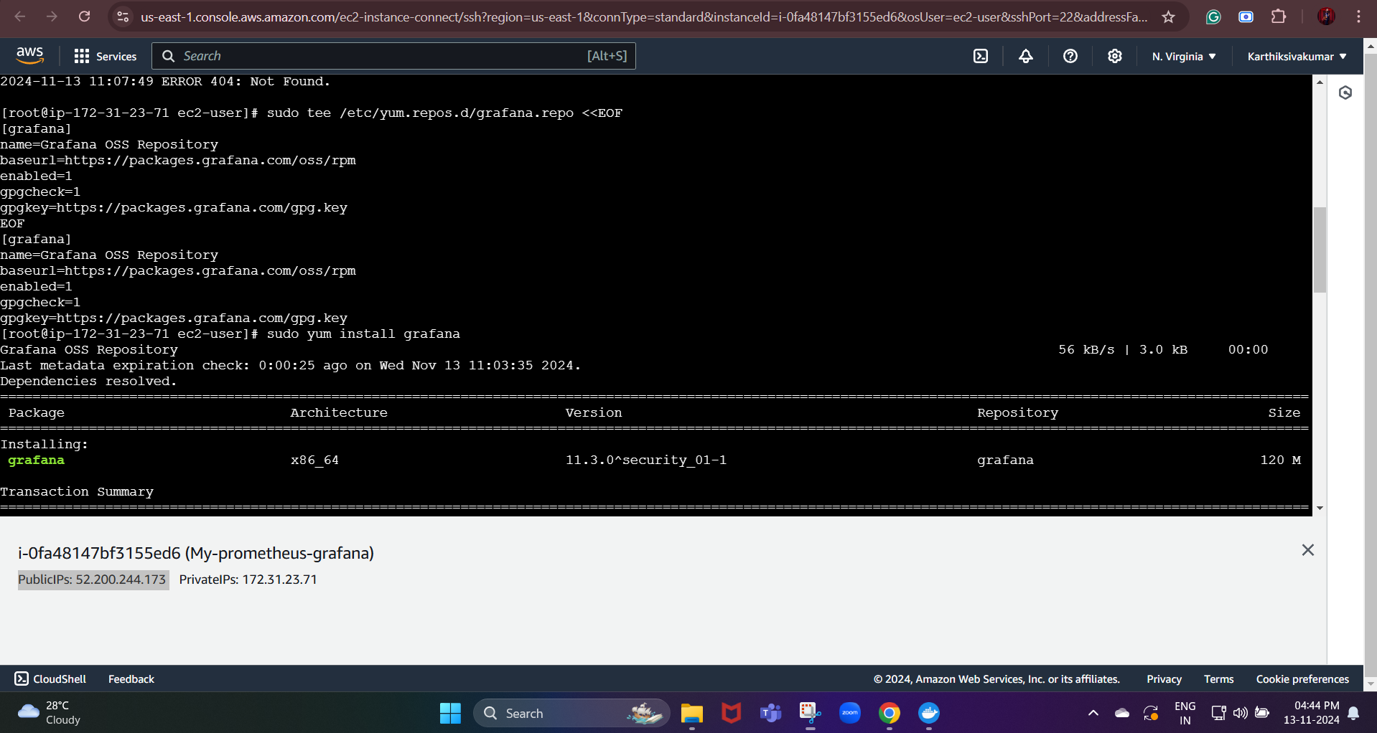

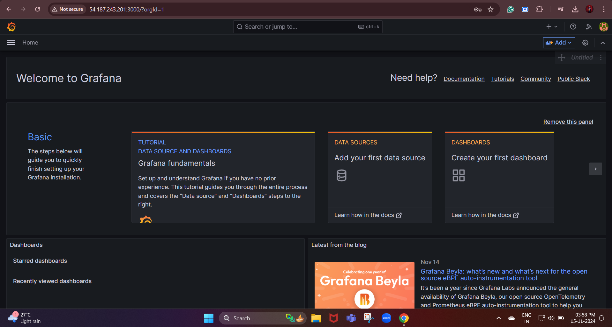

http://52.200.244.173:3000

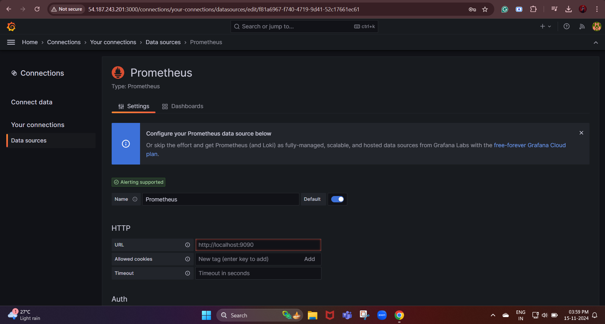

We need to add Prometheus in data source

http://54.187.243.201:9090

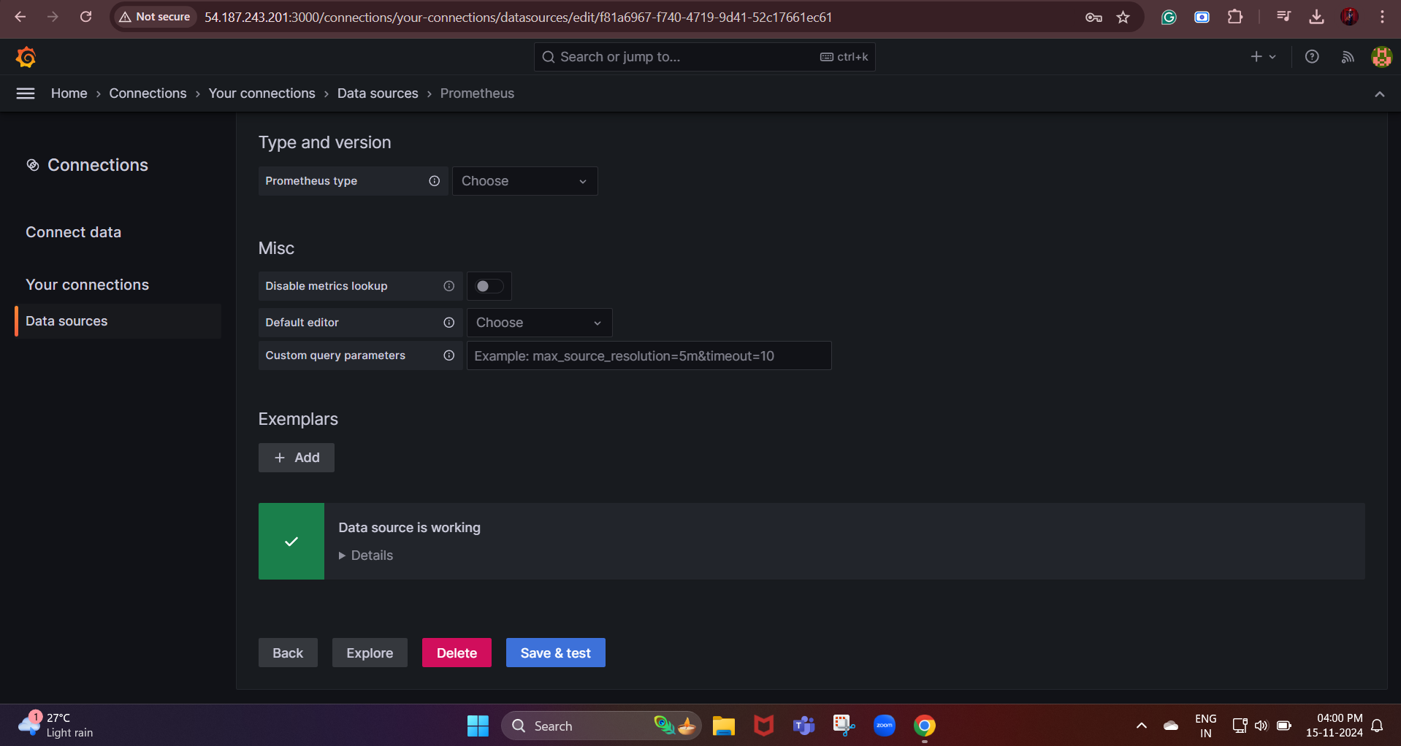

Grafana is connected to the Prometheus now

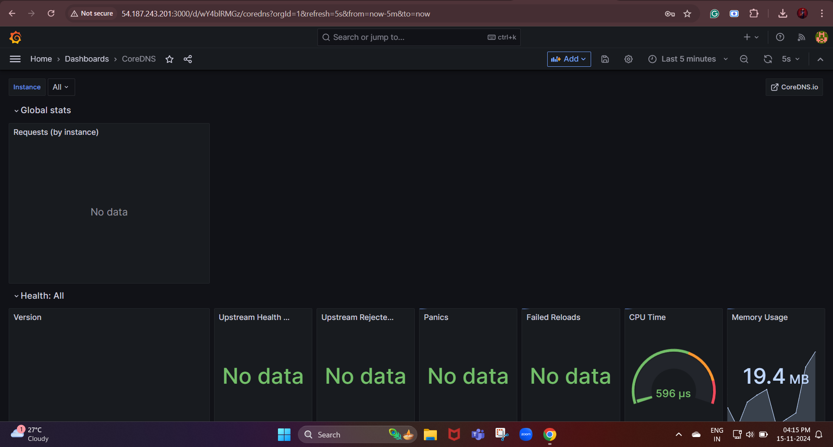

Dashboard link:

http://54.187.243.201:3000/d/wY4blRMGz/coredns?orgId=1&refresh=5s&from=1731664554116&to=1731668154116&theme=light